Candidate Number 2017

Centre Number 65345

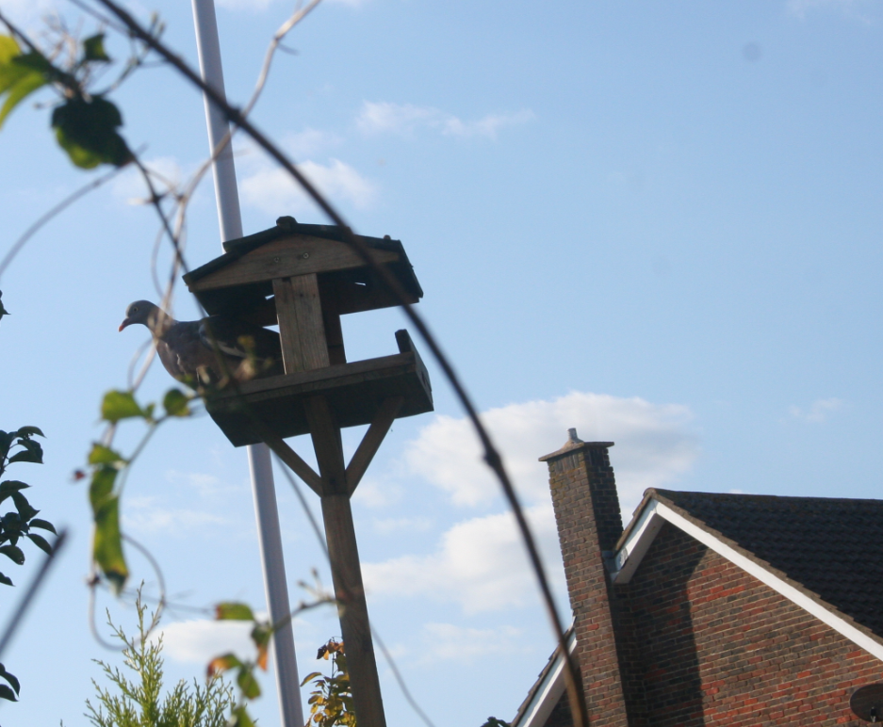
Jack George Henry Hawkins

A BIRD TABLE WHICH REPELS UNWANTED VISITORS

CONTENTS

Context and Objectives 1
Action Plan 2
Research
- Research Plan 3
- Garden Birds 4
- Bird Tables 6
- Comparison of Micro Controller Boards 8
- Design Specification 9
Development
- Comparison of Detection Methods 11
- Comparison of Repel Methods 20
- Sketches 21
- Concept Models 27
- Solidworks Drawings 29
- Materials 35
Construction
- Quality Assurance Checks 37
- Plan for Production 38
- CAD Router 39
- Bird Table 40
- Circuit & Software 44
Evaluation
- Assembly & Calibration 48
- Practical Use 50
- Users View 52
- Evaluation of Design Specification 54
- Evaluation of Action Plan 56
- Improvements & Commercial Opportunities 57
- Large scale production 59

